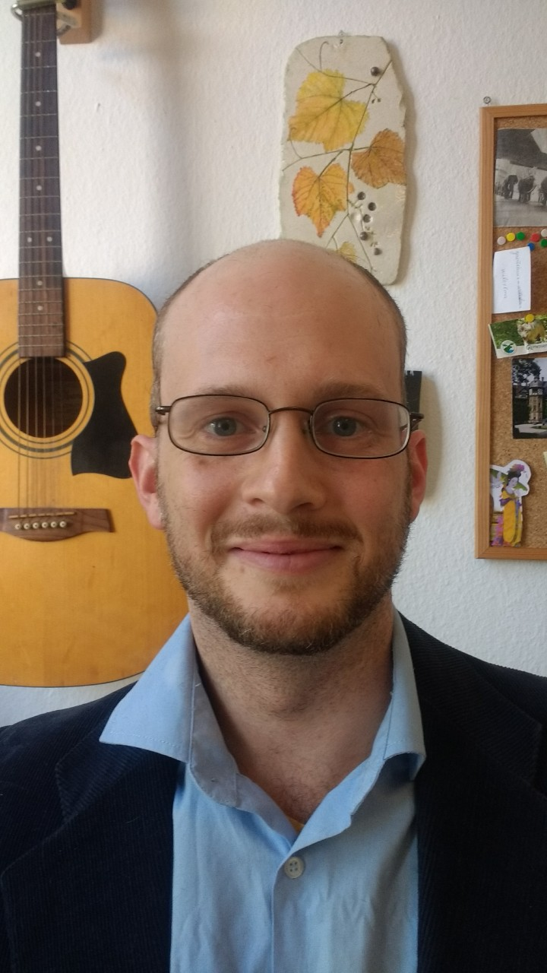

PERSONAL INFORMATION
Family name, First name: Toscani, Matteo
Researcher unique identifier: http://www.researcherid.com/rid/R-7347-2018
Date of birth: 24.01.1985
Nationality: Italian
Family status: married, one daughter
URL for web site: http://www.allpsych.uni-giessen.de/toscani

I did my undergraduate work in Florence (Italy), followed by an MSc thesis on the electroencephalographic correlates of visual sensitivity. After my graduation I moved to Giessen (Germany) to work in one of Europe’s top vision laboratories. There I developed interest in visual appearance of complex realistic stimuli; and specifically how their lightness is affected by the way we move our eyes. After finishing my thesis, a position as an independent PostDoc allowed me to take advantage of the great research environment in Giessen. I extended my horizon by working on color with Karl Gegenfurtner, and lately on the perception of material properties with Roland Fleming and Katja Dörschner. I am currently pursuing collaborations with the haptics group of Knut Drewing in Giessen.

- EDUCATION

2013 PhD in Natural Sciences
Department of Psychology, Justus-Liebig-Universität Gießen, Germany
Name of PhD Supervisor: Karl Reinhard Gegenfurtner
2009 M.Sc in Experimental Psychology (Laurea Specialistica).
Department of Psychology, University of Florence, Italy
2007 B.Sc in General and Experimental Psychology (Laurea Triennale).
Department of Psychology, University of Florence, Italy

- CURRENT POSITION(S)

2013 – Post-doctoral fellow
Department of Psychology, Justus-Liebig-Universität Gießen, Germany

- PREVIOUS POSITIONS

2010 – 2013 PhD student
Department of Psychology, Justus-Liebig-Universität Gießen, Germany

- FELLOWSHIPS AND AWARDS

2018 Best paper award – Eurohaptics Conference, Pisa, Italy
2014 Best PhD Dissertation award, Giessen, Germany
2012 Student award. European Conference on Visual Perception, Alghero, Italy
2012 Travel Grant. From points and lines, to surfaces and volumes, Rovereto, Italy
2010 Fellowship for the European Summer School Visual Neurosciences, Rauischholzhausen, Germany

- TEACHING ACTIVITIES AND SUPERVISION OF GRADUATE STUDENTS

2012 -2018 European Summer School of Visual Neuroscience – from spikes to awareness. Tutorial on color perception.
2010-2018. Supervision of several Master and Bachelor students. Department of Psychology, Justus- Liebig-Universität Gießen, Germany

- COMMISSIONS OF TRUST
Adhoc reviewer for the following scientific journals: Art & Perception, Brain Sciences, Frontiers in Psychology, IEEE Transactions on Haptics, i-Perception, Journal of Experimental Psychology, Journal of Vision, Optik – International Journal for Light and Electron Optics, PLoS ONE, Psihologija, Psychological Research, Vision,Vision Research.

And for the following conferences: ACM SIGGRAPH VRCAI 2019, IEE Eurohaptics 2020.

I am a member of the program committee of CVCS 2020 (Color and Visual Computing Symposium 2020).

- COLLABORATIONS

Alexander Schütz, peripheral vision, metacognition. Department of Psychology, Philipps-Universität Marburg
Christoph Witzel, color vision. Department of Psychology, University of Southampton, UK
Giuseppe Claudio Guarnera, material perception. Computer Vision and Pattern Recognition Research Group, University of York, UK
Jon Yngve Hardeberg, material perception. Department of Computer Science, NTNU in Gjøvik
Katja Doerschner, material and color perception. Department of General Psychology, Justus-Liebig-University, Germany
Knut Drewing, haptic perception. Department of General Psychology, Justus-Liebig-University, Germany
Matteo Valsecchi, peripheral vision, metacognition. Department of Psychology, University of Bologna, Italy
Pascal Mamassian, metacognition. Laboratoire des Systèmes Perceptifs, Ecole Normale Supérieure, France
Roland Fleming, material perception. Department of General Psychology, Justus-Liebig-University, Germany
Sunčica Zdravković, lightness perception. Laboratory for Experimental Psychology, Faculty of Philosophy, University of Belgrade, Serbia

- SCIENTIFIC PRODUCTION

Prizes / Awards
2018 Best paper award – Eurohaptics, Pisa, Italy
2014 Best PhD Dissertation award, Giessen, Germany
2012 Student award. European Conference on Visual Perception, Alghero, Italy
2012 Travel Grant. From points and lines, to surfaces and volumes, Rovereto, Italy
2010 Fellowship for the European Summer School Visual Neurosciences, Rauischholzhausen,
Germany

Total citations: Web of Science: 270; Google Scholar: 408
H-Index: Web of Science: 9; Google Scholar: 11

Publications in international peer-reviewed scientific journals
(*Publications without PhD supervisor as co-author (Gegenfurtner, K.R.))
(+ Joined first authors)

Toscani, M., Guarnera, D., Guarnera, C., Hardeberg, J. Y., & Gegenfurtner, K. (2020). Three perceptual dimensions for specular and diffuse reflection. ACM Transactions on Applied Perception. In press.
Toscani, M., Milojevic Z., Fleming R. W. & Gegenfurtner K.R., (2020). Color consistency in the appearance of bleached fabrics. Journal of Vision. In press
*Witzel, C. & Toscani, M. (2020). How to make a #theDress. Journal of the Optical Society of America A. In press.
*Metzger, A., Toscani, M., Valsecchi, M., & Drewing, K. (2019, July). Dynamics of exploration in haptic search. In 2019 IEEE World Haptics Conference (WHC) (pp. 277-282). IEEE.
*Toscani, M., & Valsecchi, M. (2019). Lightness discrimination depends more on bright rather than shaded regions of three-dimensional objects. i-Perception, 10(6), 2041669519884335.
*Toscani+, M., Yücel+, E. I., & Doerschner, K. (2019). Gloss and speed judgments yield different fine tuning of saccadic sampling in dynamic scenes. i-Perception, 10(6), 2041669519889070.
Ennis, R., Schiller, F., Toscani, M., & Gegenfurtner, K. R. (2018). Hyperspectral database of fruits and vegetables. JOSA A, 35(4), B256-B266.
Guarnera, D. Y., Guarnera, G. C., Toscani, M., Glencross, M., Li, B., Hardeberg, J. Y., & Gegenfurtner, K. R. (2018, August). Perceptually validated analytical BRDFs parameters remapping. In ACM SIGGRAPH 2018 Talks (p. 17). ACM.
*Metzger, A., Toscani, M., Valsecchi, M., & Drewing, K. (2018, June). Haptic Saliency Model for Rigid Textured Surfaces. In International Conference on Human Haptic Sensing and Touch Enabled Computer Applications (pp. 389-400). Springer, Cham.
Milojevic, Z., Ennis, R., Toscani, M., & Gegenfurtner, K. R. (2018). Categorizing natural color distributions. Vision research, 151, 18-30.
Ennis+, R., Toscani+, M., & Gegenfurtner, K. R. (2017). Seeing lightness in the dark. Current Biology, 27(12), R586-R588.
Toscani, M., Gegenfurtner, K. R., & Valsecchi, M. (2017). Foveal to peripheral extrapolation of brightness within objects. Journal of vision, 17(9), 1-14.
Toscani, M., Gegenfurtner, K. R., & Doerschner, K. (2017). Differences in illumination estimation in# thedress. Journal of Vision, 17(1), 22-22.
Toscani, M., Valsecchi, M., & Gegenfurtner, K. R. (2017). Lightness perception for matte and glossy complex shapes. Vision research, 131, 82-95.
Toscani, M., Zdravković, S., & Gegenfurtner, K. R. (2016). Lightness perception for surfaces moving through different illumination levels. Journal of vision, 16(15), 1-18.
Gegenfurtner, K. R., Bloj, M., & Toscani, M. (2015). The many colours of ‘the dress’. Current Biology, 25(13), R543-R544.
Toscani, M., Valsecchi, M., & Gegenfurtner, K. R. (2015, March). Effect of fixation positions on perception of lightness. In Human Vision and Electronic Imaging XX (Vol. 9394, p. 93940R). International Society for Optics and Photonics.
Wiebel, C. B., Toscani, M., & Gegenfurtner, K. R. (2015). Statistical correlates of perceived gloss in natural images. Vision research, 115, 175-187.
Toscani, M., Valsecchi, M., & Gegenfurtner, K. R. (2013). Optimal sampling of visual information for lightness judgments. Proceedings of the National Academy of Sciences, 110(27), 11163-11168.
Toscani, M., Valsecchi, M., & Gegenfurtner, K. R. (2013). Selection of visual information for lightness judgements by eye movements. Phil. Trans. R. Soc. B, 368(1628), 20130056.
Valsecchi, M., Toscani, M., & Gegenfurtner, K. R. (2013). Perceived numerosity is reduced in peripheral vision. Journal of Vision, 13(13), 1-16.
Granzier, J. J., Toscani, M., & Gegenfurtner, K. R. (2012). Role of eye movements in chromatic induction. JOSA A, 29(2), A353-A365.
*Righi, S., Marzi, T., Toscani, M., Baldassi, S., Ottonello, S., & Viggiano, M. P. (2012). Fearful expressions enhance recognition memory: electrophysiological evidence. Acta psychologica, 139(1), 7-18.
Toscani, M., Valsecchi, M., & Gegenfurtner, K. R. (2012). The Optimal Estimator of Objects’ Lightness. In Predicting Perceptions: Proceedings of the 3rd International Conference on Appearance (p. 167). Lulu.com.
*Toscani, M., Marzi, T., Righi, S., Viggiano, M. P., & Baldassi, S. (2010). Alpha waves: a neural signature of visual suppression. Experimental brain research, 207(3-4), 213-219

Contribution in conferences

November 2019. Sorrento (Italy): Oral presentation: "Assessment of OLED Head Mounted Display for vision research with Virtual Reality" (Toscani M, Gil R, Guarnera D, Guarnera GC, Kalouaz A, Gegenfurtner KR) at the IEEE Conference on Signal Image Technology and Internet based Systems (SITIS).
August 2019. Leuven (Belgium): Oral presentation: "Heterochromatic Brightness" (Gegenfurtner KR, Chen J, Toscani M, Valsecchi M, Chadwick A, van Doorn A, Koenderink J) at the European Conference on Visual Perception.
July 2019. Tokyo (Japan): Oral presentation: " Dynamics of exploration in haptic search" (Metzger A, Toscani M, Valsecchi M, Drewing K) at the World Haptics Conference (WHC).
May 2019. Naples (Florida): Poster presentation: "Under-confidence in peripheral vision" (Toscani M, Gegenfurtner KR, Mamassian P, Valsecchi M) at the Vision Science Society Annual Meeting.
May 2019. Naples (Florida): Poster presentation: "Initial fixations differ for brightness and stiffness judgements" (Alley LM, Toscani M, Ennis RJ, Doerschner K) at the Vision Science Society Annual Meeting.
August 2018. Trieste (Italy): Oral presentation: "A Role for Metallicity in the Perception of Surface Reflectance" (Toscani M, Guarnera D, Guarnera GC, Hardeberg JY, Gegenfurtner KR) at the European Conference on Visual Perception.
August 2018. Trieste (Italy): Poster presentation: "Different Fixation Patterns in Dynamic Scenes for Lightness and Stiffness Judgements" (Alley LM, Toscani M, Doerschner K) at the European Conference on Visual Perception.
June 2018. Pisa (Italy): Oral presentation: "Haptic Saliency Model for Rigid Textured Surfaces". ( Metzger A, Toscani M, Valsecchi M, Drewing K) at the EuroHaptics Annual Meeting.
May 2018. Naples (Florida): Poster presentation: "Visual sensitivity to material differences". (Toscani M, Guarnera D, Guarnera GC, Hardeberg JY, Gegenfurtner KR) at the Vision Science Society Annual Meeting.
August-September 2016. Barcelona (Spain): Oral presentation: "Object selective influence of fixated luminance on brightness perception in the periphery of the visual field" (Toscani M, Valsecchi M, Gegenfurtner KR) at the European Conference on Visual Perception.
August-September 2016. Barcelona (Spain): Oral presentation: "Giessen’s hyperspectral images of fruits and vegetables database (GHIFVD)" (Ennis RJ, Toscani M, Schiller F, Hansen T, Gegenfurtner KR) at the European Conference on Visual Perception.
May 2016. Naples (Florida): Poster presentation: "Probing the illumination on #The Dress". (Toscani M, Gegenfurtner KR, Doerschner K) at the Vision Science Society Annual Meeting.
August 2015. Liverpool (UK): Oral presentation: "Scotopic lightness perception" (Ennis RJ, Toscani M, Gegenfurtner KR) at the European Conference on Visual Perception.
August 2014. Belgrade (Serbia): Oral presentation: "Perceived lightness over space and time" (Toscani M, Zdravković S, Gegenfurtner KR) at the European Conference on Visual Perception.
May 2014. Naples (Florida): Poster presentation: "Predicting lightness rankings from image statistics of matte and glossy surfaces". (Toscani M, Valsecchi M, Gegenfurtner KR) at the Vision Science Society Annual Meeting.
August 2013. Bremen (Germany): Oral presentation: "Perceived numerosity in the peripheral visual field" (Valsecchi M, Toscani M, Gegenfurtner KR)
August 2013. Bremen (Germany): Oral presentation: "Predicting lightness judgments from luminance distributions of matte and glossy virtual objects " (Toscani M, Valsecchi M, Dilger MD, Zirbes A, Gegenfurtner KR) at the European Conference on Visual Perception.
May 2013. Naples (Florida): Poster presentation: "Lightness perception for glossy objects". (Toscani M, Valsecchi M, Gegenfurtner KR) at the Vision Science Society Annual Meeting.
September 2012. Alghero (Italy): Poster presentation: "Spatial frequency overestimation with retinal eccentricity for isoluminant chromatic gratings " (Toscani M, Valsecchi M, Gegenfurtner KR) at the European Conference on Visual Perception.
September 2012. Alghero (Italy): Poster presentation: "Perceived numerosity in the peripheral visual ﬁeld" (Valsecchi M, Toscani M, Gegenfurtner KR) at the European Conference on Visual Perception.
May 2012. Naples (Florida): Poster presentation: "The optimal estimator of lightness" (Toscani M, Valsecchi M, Gegenfurtner KR) at the Vision Science Society Annual Meeting.
April 2012. Edinburgh (UK): Oral presentation: " The Optimal Estimator of Objects’ Lightness" (Toscani M, Valsecchi M, Gegenfurtner KR) at the "Predicting Perception" 3rd Conference on Appearance.
September 2011. Toulouse (France): Oral presentation: "A functional link between image segmentation, lightness perception and eye movements? " (Toscani M, Gegenfurtner KR) at the European Conference on Visual Perception.
September 2011. Toulouse (France): Poster presentation: " Do individual differences in eye movements explain differences in chromatic induction between subjects? " (Granzier JM, Toscani M, Gegenfurtner KR).
July 2011. Florence (Italy): Poster presentation: “The role of eye movements in lightness perception" (Toscani M, Valsecchi M, Gegenfurtner KR) at the 8th IBRO World Congress of Neuroscience.
May 2011. Naples (Florida): Poster presentation: “Where we look determines what we see" (Toscani M, Valsecchi M, Gegenfurtner KR) at the Vision Science Society Annual Meeting.

Invited talks

March 2020. Delft University of Technology, Delft (Netherlands). “The interplay between central and peripheral information sampling affects visual appearance.”

February 2020, Max Planck Institute for Empirical Aesthetics, Frankfurt (Germany). Eye-Tracking Day symposium. “The interplay between central and peripheral information sampling affects visual appearance.”

November 2019, Goethe Universität Frankfurt (Germany). Seminar at the Scene Grammar Lab. “The interaction between visual appearance and eye-movements”.

